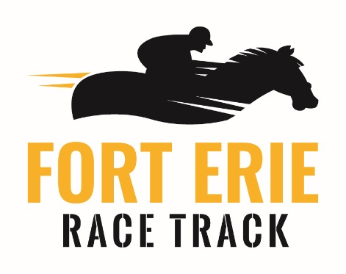
2018 Fort Erie Farmers Market
Vendors Information Form/Conditions of Exhibiting
Fort Erie Race Track will once again offer space to farmers, bakers, crafters, artisans, home businesses, etc., for this season’s Farmers Market.
Our farmers market runs in conjunction with live racing in order to ensure the most visitors. Market begins Sunday, June 10 and runs every Sunday until mid-October.

Race days and markets will run as follows:
- Sundays beginning at 12:00 pm until racing ends (about 5:00 pm.) First race begins at 1:20pm.
There will be a booth fee of $100 + HST in order to ensure your space. Please make your cheque payable to FELRC or Fort Erie Live Racing Consortium in the total amount of $113.00.
Payment and completed forms must be received on or before June 4th, 2018. Payment, along with completed forms can be dropped off at the Administration building, or mailed to:
Fort Erie Race Track
Attention – Antonietta Culic
230 Catherine Street
P.O. Box 1130
Fort Erie, Ontario
L2A 5N9

Completed forms can be emailed to femedia@forterieracetrack.ca or faxed to 905 994 3629
If you have any questions, please contact;

Antonietta Culic
Fort Erie Race Track
femedia@forterieracetrack.ca
905-871-3200 or 800-295-3770 ext. 3209

Hours of operation for Fort Erie Farmers Market
Set Up will take place any time after 10 am on each market day and must be completed a half hour prior to start time. Tear down will take place after the last race.

The location of your booth will be determined on or before June 10th. Fort Erie Race Track will contact you in advance or notify you on the first day of the market. If you are a returning vendor from 2017 and would like the same location this year, please advise.

Booths will be assigned on a first come first serve/paid basis. As you are outside we encourage you to have shelter to protect you from the elements. You must provide your own equipment such as a tent or canopy, tables, display stands, racks etc.

Please provide your contact information

Name__________________________________________________________

Phone Number___________________________________________________

Email __________________________________________________________
Please answer the following questions regarding your booth;
- What is your business name/name of booth?

- Please specify the items that you will be offering at your booth.

- Do you have any special requests?

- Will you require electrical courtesy of Fort Erie Race Track? Yes / No

- Do you have a tent? Yes / No

- Will you be selling food or edible items? Yes/ No
(If yes, please note that food vendors are required to submit their information online to public health at https://www.niagararegion.ca/living/health_wellness/inspection/farmers-market-vendor-application.aspx no later than May 10, 2018.

Please provide a short description (1-2 sentences) about your booth and products.

Conditions of Exhibiting

- The Fort Erie Race Track is not responsible for any loss or damage as a result of vandalism or an act of nature.
- The Fort Erie Race Track reserves the right to set site locations and relocate exhibits.
- It is the sole responsibility of the exhibitor to ensure that their exhibit and surrounding area is safe and free of hazards and to follow the instructions of race track staff while onsite.
- Sales permits and collection of all appropriate sales taxes is the sole responsibility of the exhibitor.
- I understand that this document also serves as a media release form; encompassing all possible media coverage and formats, including photos.
- No refunds, for any reason, will be given for cancellations.

Regulations

- Vendors CANNOT sell: hot dogs, hamburgers, French fries, pop, water and/or alcoholic beverages
- Food items must comply with the Niagara Regional Health Guidelines and complete attached Health and Safety Responsibility Agreement, and submit the online application form.
- Fort Erie Race Track reserves the right to approve each vendor
- Niagara Health Inspection and food safety guidelines will apply. Some restrictions may be in place regarding types of prepared food permitted on the grounds of Fort Erie Race Track.
- Fort Erie Race Track will not be responsible for any loss or damage which may occur to any artwork or goods while on the premises.
- No trucks will be allowed to park in the market area, vendors must use tables and tents only
- A vendor shall occupy a stall by 11am for a 1:20 post time. Failing which the Market Clerk may assign occupancy to another vendor.
- A vendor shall notify the Market Clerk (Fort Erie Race Track) at least one day prior to first occupying a stall under a daily agreement and at least one day prior to not occupying their stall.

No Person Shall
- Sell or distribute anything at Fort Erie Race Track except in accordance with the provisions of this Bylaw
- Place or leave any property in the Market except in accordance with the Bylaw
- Shout, commit any nuisance or be disorderly
- Expose or offer any food items which are in any way unsound or unfit for human consumption, considered second rate goods or fail to conform to applicable health protection, grading or packaging legislation and regulations
- Leave any refuse or waste in the Market area
- Fail to keep , any stall occupied in a clean and orderly state
- Use any natural gas, electrical or propane equipment which is in unsafe condition and does not comply with C.S.A. standards
- Load or unload from areas other than those designated
- Vendors are financially responsible for any damage to their designated site that may require maintenance repair (example, damage to fencing)

I agree to the terms and conditions as stated in this contract for exhibiting in the Fort Erie Farmers Market.

Date___________________ Signature ____________________________________________

